

## Test One

## Semester One 2018 UNIT 1 METHODS

## Calculator Assumed 40 minutes /45 marks

## Scientific Calculator, ClassPad, Formula Sheet and One page one side of A4 notes is permitted

**Name:**

Place a tick in the box next to your Mathematics teachers name:

|  |  |
| --- | --- |
| **Mr Strain** | **□** |
| **Ms Sindel** | **□** |
| **Ms Rimando** | **□** |
| **Mr Gannon** | **□** |
| **Mr Young** | **□** |
| **Mrs Flynn** | **□** |
| **Ms Ensly** | **□** |
|  |  |

**Question 1 (2, 2, 2 = 6 marks)**

Consider the following points, A $(4,9)$ and B $(20,12)$.

1. Determine the distance from point A to B.
2. Determine the midpoint between points A and B.
3. If point B was the midpoint of points A and point C. Determine the coordinates of point C.

**Question 2 (2, 2, 1, 3 = 8 marks)**

Determine the equation of a line that passes through the point $(-10, 3)$ and :

1. passes through the point $\left(5,-7\right).$
2. is parallel to the line .
3. is parallel to the y axis.
4. is perpendicular to the line $x-4y=9.$

**Question 3 (2, 3, 3 = 8 marks)**

Consider the line $5x+my=21$, where  is a constant.

1. In terms of , determine the y intercept.
2. In terms of , determine the midpoint of the x and y intercepts.
3. Determine the value of so that the line will never cross $y=7x.$

**Question 4 (1, 1, 2 = 4 marks)**

Jessica needs to hire a car for a number of days. The hire car company has two options from which she can choose.

Budget: $15 per day plus $0.25 per km travelled

Deluxe: $42 per day for unlimited travel

i) Jessica will hire the car for n days and drive a total of x km.

a) Find an expression for the cost, $C, in terms of n for the Deluxe option.

b) Find an expression for the cost, $C, in terms of n and x, for the Budget option.

ii) If Jessica plans to drive a total of 600 km, find the maximum number of days for which she can hire the car so that it is cheaper for her to take the Deluxe option.

**Question 5 (2, 2, 2 = 6 marks)**

Factorise the following expressions:

$4x^{2}y-12xy^{4}$

$x^{3}-3x^{2}-9x+27$

$18x^{2}+33x-30$

**Question 6 (5 marks)**

On the axes below, sketch the parabola $y=-2{\left(x+3\right)}^{2}+6$ showing all major features.

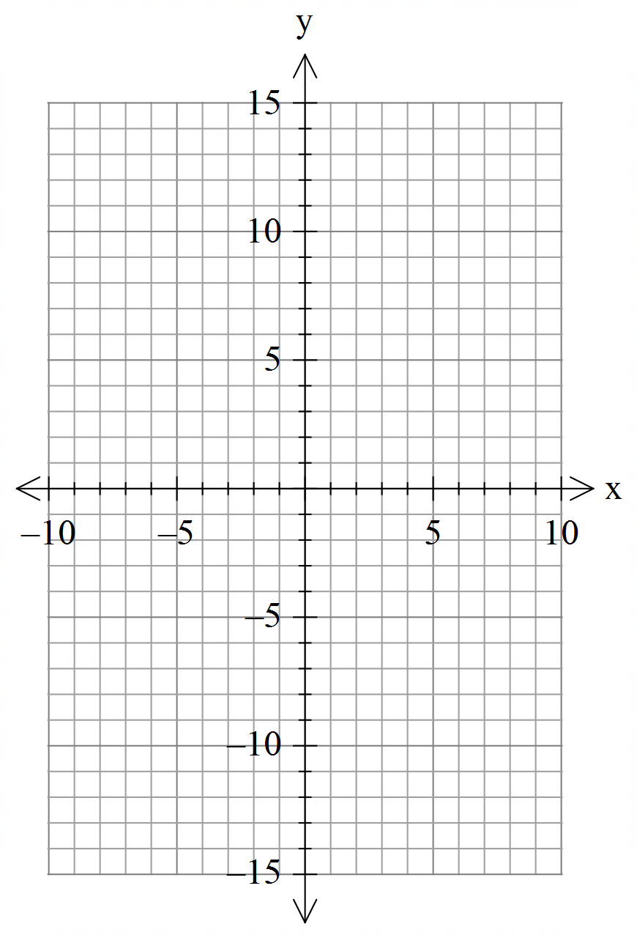

**Question 7 (2, 2 =4 marks)**

For each of the following write down the equation of a parabola that satisfies the following:

(No need to simplify)

1. A quadratic with intercepts $\left(4,0\right)$ and $(-7,0)$ with a y intercept of (0, -56).
2. A quadratic with a maximum turning point $(7,1)$ and an $x$ intercept $\left(10,0\right).$

**Question 8 (4 marks)**

Determine the value of  for the shape below.

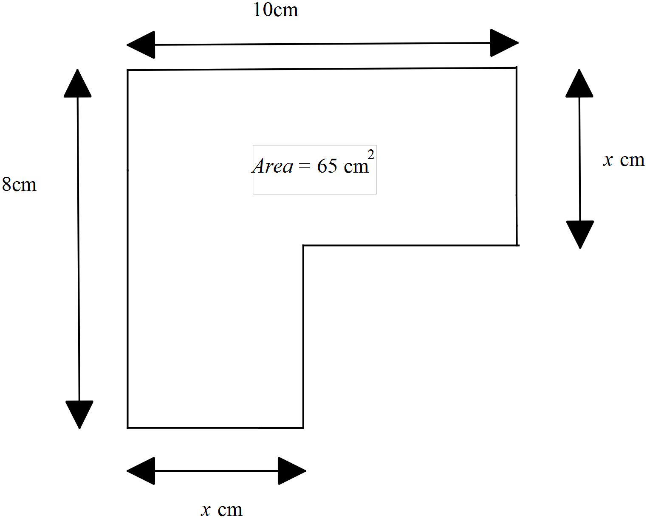

End of test